Cheetah

Use-Case Specification: Create Text

Version 1.0

Revision History

|  |  |  |  |
| --- | --- | --- | --- |
| **Date** | **Version** | **Description** | **Author** |
| 11/04/2017 | 1.0 | Initial Version | Damian Pistorius, Lior Olszewski, Sara Olszewski |
|  |  |  |  |
|  |  |  |  |
|  |  |  |  |

Table of Contents

1. Use-Case Name 4

1.1 Brief Description 4

2. Flow of Events 4

2.1 Basic Flow 4

3. Special Requirements 5

3.1 Functionality in the Browser 5

4. Preconditions 5

4.1 Log-In 5

5. Postconditions 5

5.1 Submit 5

6. Extension Points 5

Use-Case Specification: Create Text

# Use-Case Name

## Brief Description

This use case allows the students to comment on any text file, to draw attention on mistakes or to present a solution.

# Flow of Events

## Basic Flow

**Activity Diagram:**



**Mock-Up:**

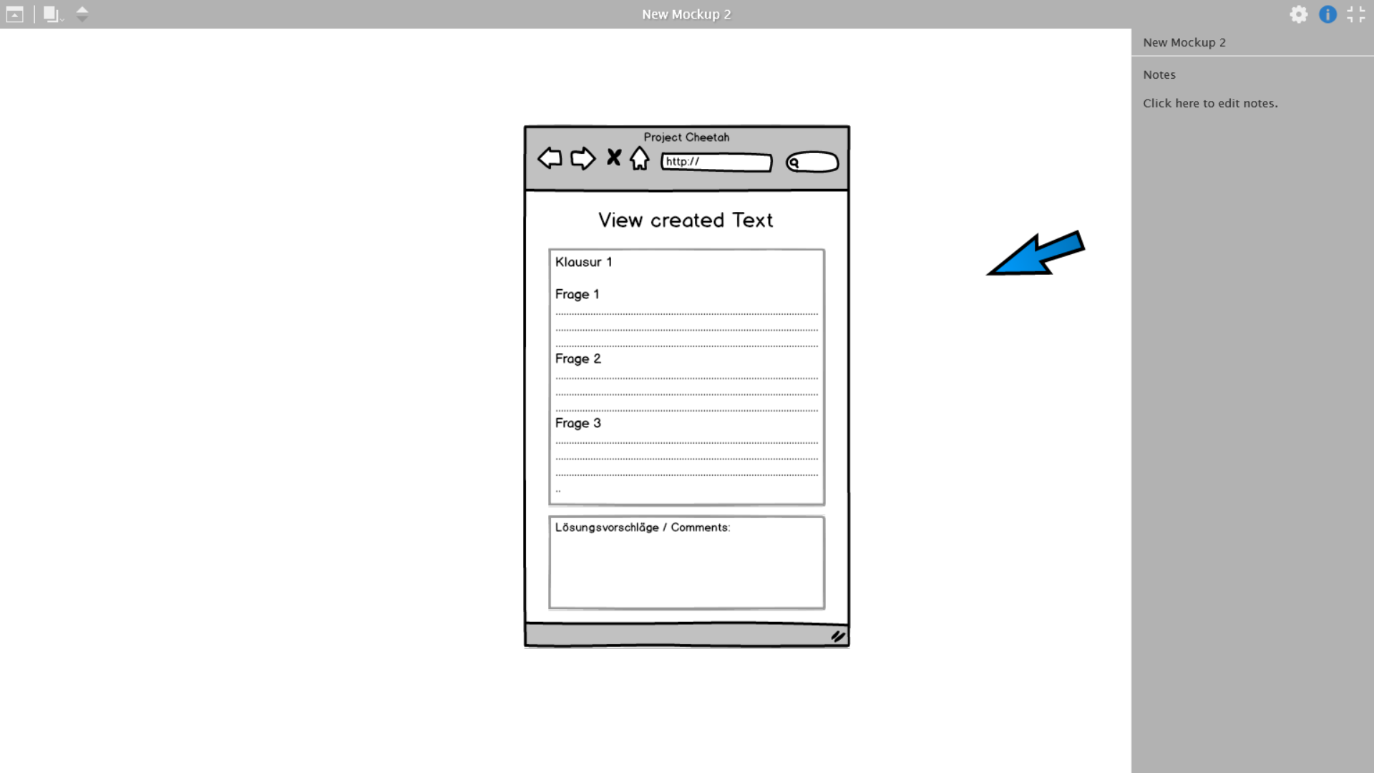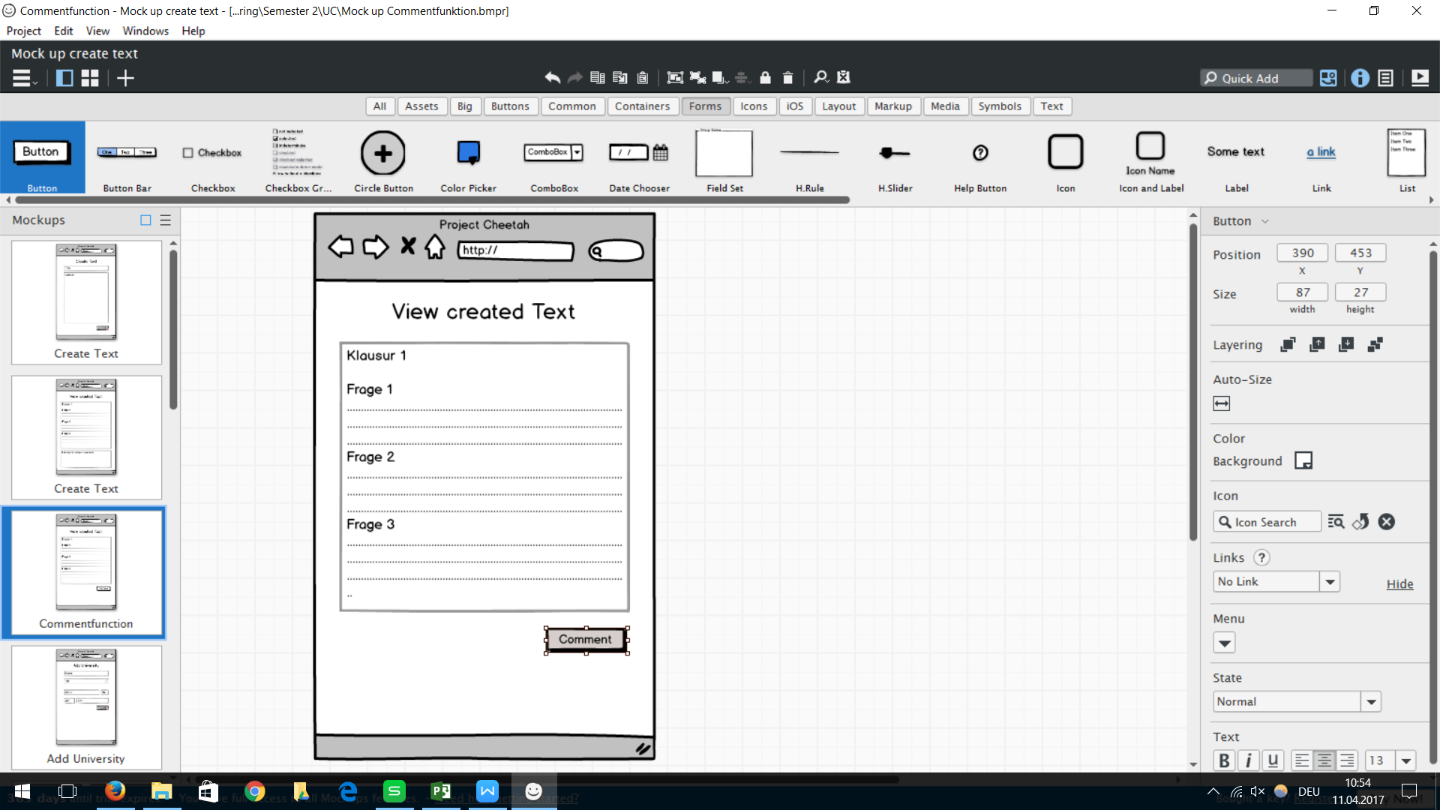

# Special Requirements

## Functionality in the Browser

Since it will be a web application, it should fit every browser. It should have a responsive design.

# Preconditions

## Log-In

The student has to be registered and logged in.

# Postconditions

## Submit

The student has to press the enter button so the database can save the new created comment.

# Extension Points

N/A